# HRMS Product Requirement Document (PRD)

**1.1 Overview**

The HRMS with Payroll Management is a comprehensive system designed to manage employee information, attendance, leave, performance, and payroll processes. It automates salary computation, tax deductions, benefits allocation, and payslip generation. The solution is accessible via web and mobile platforms.

**1.2 Objectives**

* Centralize HR functions (employee records, attendance, leave)
* Automate payroll with accurate tax compliance
* Provide self-service portals for employees and HR
* Integrate with biometric attendance devices
* Ensure secure and auditable records

**1.3 Scope**

**Core HR**

* Employee profile management
* Attendance & leave tracking
* Document management
* Performance reviews

**Payroll Management**

* Salary structure definition
* Earnings & deductions
* Tax & compliance (PF, ESI, TDS, gratuity)
* Monthly payroll runs
* Payslip generation & distribution
* Bank transfer file generation

**Reports & Analytics**

* Payroll reports
* Tax summaries
* Leave balance reports
* Employee attrition analytics

**1.4 Stakeholders**

* HR Department
* Finance Department
* Employees
* Management

**1.5 Functional Requirements**

* Employee CRUD
* Attendance integration
* Leave application & approval workflow
* Payroll computation engine
* Tax calculation & compliance reports
* Role-based access control
* Notification system (Email, SMS, Portal alerts)

**1.6 Non-Functional Requirements**

* Scalability to handle 50,000+ employees
* Secure authentication & data encryption
* Response time < 2 seconds for UI actions
* Cloud-ready deployment (AWS/Azure)

**2. High-Level Design (HLD)**

**Architecture Overview:**

* **Frontend**: Angular/React for Web, Flutter for Mobile
* **Backend**: Spring Boot microservices
* **Database**: PostgreSQL for transactional data
* **Integration**: Apache Camel for data pipelines
* **Messaging**: Kafka for payroll event processing
* **Authentication**: Key cloak (OIDC + SSO)

**Services in HLD:**

1. **Employee Service** – Manages employee data
2. **Attendance Service** – Biometric device integration
3. **Leave Management Service** – Tracks leave balances and requests
4. **Payroll Service** – Salary computation & payslip generation
5. **Notification Service** – Sends alerts
6. **Report Service** – Generates reports
7. **Auth Service** – Manages user authentication & authorization

**HLD Diagram**

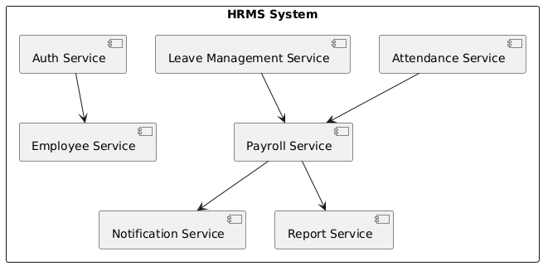

**Sequence Diagram**

**Database Schema (Core Tables)**

**ER Diagram**

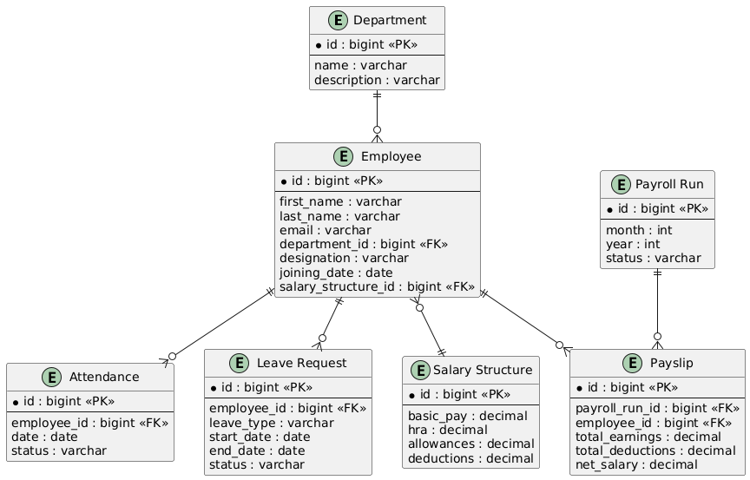

**SQL DDL Script**

CREATE TABLE department (

id BIGSERIAL PRIMARY KEY,

name VARCHAR(100) NOT NULL,

description TEXT

);

CREATE TABLE salary_structure (

id BIGSERIAL PRIMARY KEY,

basic_pay DECIMAL(10,2) NOT NULL,

hra DECIMAL(10,2),

allowances DECIMAL(10,2),

deductions DECIMAL(10,2)

);

CREATE TABLE employee (

id BIGSERIAL PRIMARY KEY,

first_name VARCHAR(50) NOT NULL,

last_name VARCHAR(50),

email VARCHAR(100) UNIQUE NOT NULL,

department_id BIGINT REFERENCES department(id),

designation VARCHAR(50),

joining_date DATE NOT NULL,

salary_structure_id BIGINT REFERENCES salary_structure(id)

);

CREATE TABLE attendance (

id BIGSERIAL PRIMARY KEY,

employee_id BIGINT REFERENCES employee(id),

date DATE NOT NULL,

status VARCHAR(20) CHECK (status IN ('Present','Absent','Leave'))

);

CREATE TABLE leave_request (

id BIGSERIAL PRIMARY KEY,

employee_id BIGINT REFERENCES employee(id),

leave_type VARCHAR(50),

start_date DATE NOT NULL,

end_date DATE NOT NULL,

status VARCHAR(20) CHECK (status IN ('Pending','Approved','Rejected'))

);

CREATE TABLE payroll_run (

id BIGSERIAL PRIMARY KEY,

month INT CHECK (month BETWEEN 1 AND 12),

year INT,

status VARCHAR(20) CHECK (status IN ('Pending','Completed'))

);

CREATE TABLE payslip (

id BIGSERIAL PRIMARY KEY,

payroll_run_id BIGINT REFERENCES payroll_run(id),

employee_id BIGINT REFERENCES employee(id),

total_earnings DECIMAL(10,2),

total_deductions DECIMAL(10,2),

net_salary DECIMAL(10,2)

);

## **API Design (Sample)**

**POST /api/payroll/run** – Trigger payroll calculation  
**GET /api/payroll/{month}/{year}/payslips** – Fetch payslips for a period  
**GET /api/employee/{id}** – Fetch employee details  
**POST /api/leave/request** – Apply for leave

**Test Cases**

| **Test Case ID** | **Scenario** | **Steps** | **Expected Result** |
| --- | --- | --- | --- |
| TC_PAY_001 | Payroll Run | Initiate run for August 2025 | Payslips generated |
| TC_PAY_002 | Leave Deduction | Employee on leave | Salary reduced accordingly |
| TC_PAY_003 | Tax Calculation | Apply TDS rules | Tax deducted accurately |